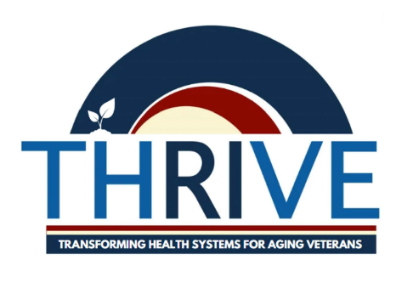
Transformative Health Systems Research to Improve Veteran Equity (THRIVE) Center of Innovation (COIN)
Leadership:
- Director: Dr. James Rudolph
- Associate Directors: Dr. Jennifer Sullivan & Dr. Stefan Gravenstein
Background:
The THRIVE COIN (formerly LTSS-COIN) focuses on advancing the Veterans Health Administration's Long-Term Services and Supports (LTSS) system. LTSS assists Veterans with disabilities, disease, or aging-related functional deficits, providing a range of care options from in-home support to nursing home and palliative care. THRIVE's mission is to honor Veterans’ preferences for health, independence, and well-being by developing expertise, programs, and partnerships that enhance the quality, safety, and equity of LTSS.
Significance:
As the Veteran population ages and faces increasing comorbidity, there is a growing demand for LTSS to support functional independence and prevent institutionalization. THRIVE addresses this by actively engaging with the VA’s Geriatrics and Extended Care (GEC) to foster a Learning Health System (LHS). The LHS continuously improves through research and innovation, focusing on the evolving needs of Veterans, including those impacted by the COVID-19 pandemic, toxic exposures, social needs, and homelessness.
Impact Goals & Priorities:
Impact Goal 1: Improve Quality, Safety, and Value of LTSS Programs using the HSR LHS Lifecycle: The VA LTSS system encompasses a dozen programs that would benefit from continual improvement to measure quality and safety. The LTSS value equation is incomplete without these measures and thus LTSS expansion remains challenged. By using the LHS lifecycles, THRIVE will propose research with the intention of LTSS delivery system implementation.
Impact Goal 2: Build and implement effective practices to address Disparities in Access and Equity: While VA LTSS are robust, there is tremendous variability in the programs and availability at VA medical centers resulting in access disparities. Our work will focus on building, testing, and implementing practices that reduce disparities and result in a more equitable distribution of LTSS.
Additional Contribution Areas:
THRIVE contributes to research in mental health and suicide prevention focused on older Veterans/LTSS. This collaboration aligns LTSS research with ongoing efforts to address mental health challenges and reduce Veteran suicide rates.
Innovation and Emerging Areas:
- Training Pathways for LTSS Researchers: THRIVE aims to build a comprehensive training program, from undergraduate to junior faculty, to cultivate the next generation of researchers in LTSS and further advance the LHS framework.
- Pharmacologic Intervention in Later Life (PILL): This area focuses on drug efficacy and improving care in later life, particularly as medication guidelines, indications, and vaccines are rapidly changing.
Partnerships & Support for Research Enterprise:
THRIVE collaborates with several key VA offices, including Geriatrics and Extended Care (GEC), the Office of Health Equity (OHE), the Office of Social Work (OSW), the National Center for Veterans Affected by Homelessness (NCVAH), Pharmacy Benefits Management (PBM), and the Office of Mental Health and Suicide Prevention (OMHSP). Additionally, THRIVE works closely with VISN 1 and the Providence VA (VAPHS) to evaluate and improve LTSS programs in line with its impact goals.

